Reception Home Learning Kensa Class week 4 - 4/5/2020
 | Monday | Tuesday | Wednesday | Thursday | Friday
Reading | Live phonics lessons can be found online on Ruth Miskin’s RWI Youtube channel (see email for links).  Red Group set 2 sounds  - Set 2 Speed Sounds and Word Time 10.00 am  - Set 2 Spelling 10.15am  Pink group & Grey group set 3 sounds  - Set 3 Speed Sounds and Word Time 10.30 am  Set 3 Spelling 10.45 am
Some ideas for you to try.  If you would like to explore more ideas look at  https://abcdoes.com/home-learning/ | 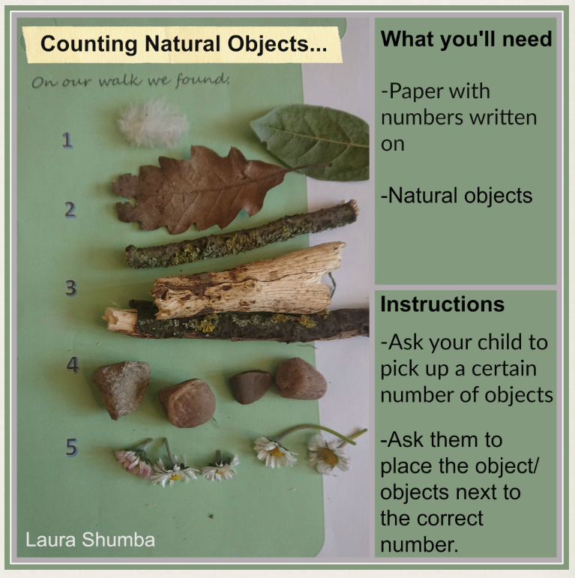 |  | 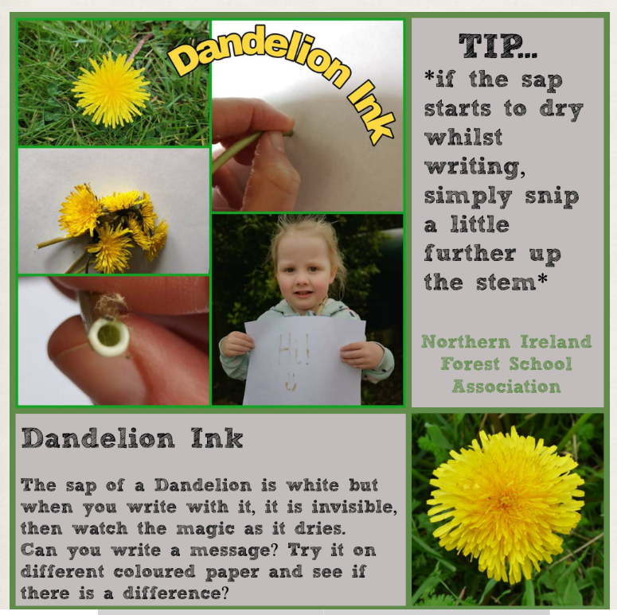 |  | Today is a Bank Holiday so no work today unless you need a routine or want to finish off any work you have started!
Maths | https://whiterosemaths.com/homelearning/ continue with White Rose planning from wherever you have reached or complete the maths lessons below.
PE/Activity | This is a link to Cosmic Kids yoga: https://www.cosmickids.com/category/watch/. You can watch this on a phone, ipad or computer. There are relaxation clips, shorter and longer yoga clips and funny dance clips.  If you can’t access the internet and the weather is fine, try setting up circuit stations in the garden such as skipping, star jumps, ball bounces, sprints, burpees. Then try and increase the number of repetitions you do at each station. See how you improve with more practise!
Topic | This week, here are a selection of activities to choose from:  D&T - Thinking about food that we eat and where it comes from, are there any recipes that include ingredients you might find on a walk or in your garden? This would mean the ingredient is free and very local which is good for the environment. Research what plants you can forage locally and find a recipe to try at home. Will you be brave and try nettle soup? Here are a couple of websites which explain a little more about foraging and what you can eat:  https://www.woodlandtrust.org.uk/visiting-woods/things-to-do/foraging/  https://www.bbcgoodfood.com/howto/guide/foraging  Write a review of your food you made – did the recipe need changing or would you add a different ingredient next time to improve the taste?  WARNING: Never ever eat plants you find without checking with an adult first whether they are safe!  Literacy/ PSHE - Write a letter or email to one of the teachers or a family member, or get creative and make a postcard using the card from an old cereal box, decorate it and send it.  You can send handwritten letters to school staff using the school address or you could send an email to Mrs Harrison or Mrs Powdrill – we would love to hear from you! Email: aharrison@blislandprimary.co.uk or cpowdrill@blislandprimary.co.uk  Your Topic choice – Plan your own topic to research this week (it might go on for longer, it’s up to you). You can relate your project to our topic of plants or you can come up with your own project ideas.  - Start with something you are interested in e.g. horses, building, cooking.  - What do you know and what else would you like to find out?  - Your topic can be about ANYTHING!  Remember to send us any pictures of your work if you’d like to share what you’ve been doing. We really would love to see your home learning!
RWI Phonics youtube channel: https://www.youtube.com/channel/UCo7fbLgY2oA_cFCIg9GdxtQ
You can find out more about the lessons here: https://www.ruthmiskin.com/en/find-out-more/parents/

