Plants Quiz

What plant is this?  Who is growing it, Mrs Harrison or Mrs Powdrill?  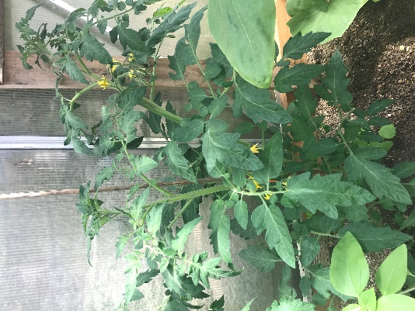 | What plant is this?  Who is growing it, Mrs Harrison or Mrs Powdrill?  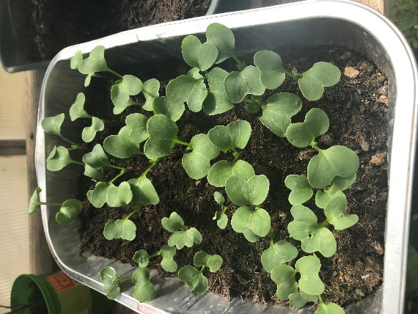
What plant is this?  Who is growing it, Mrs Harrison or Mrs Powdrill?  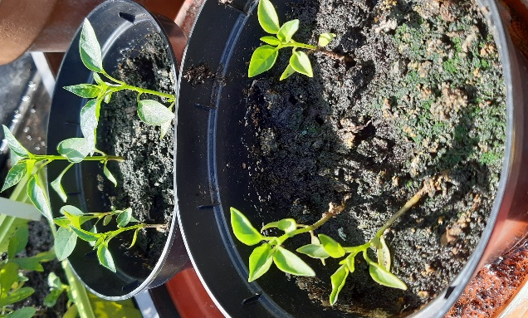 | What plant is this?  Who is growing it, Mrs Harrison or Mrs Powdrill?  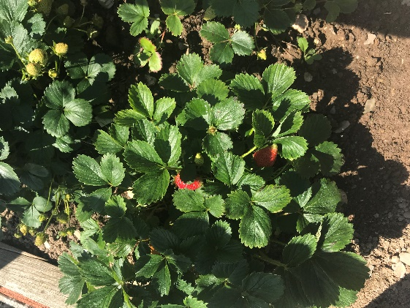
What plant is this?  Who is growing it, Mrs Harrison or Mrs Powdrill?  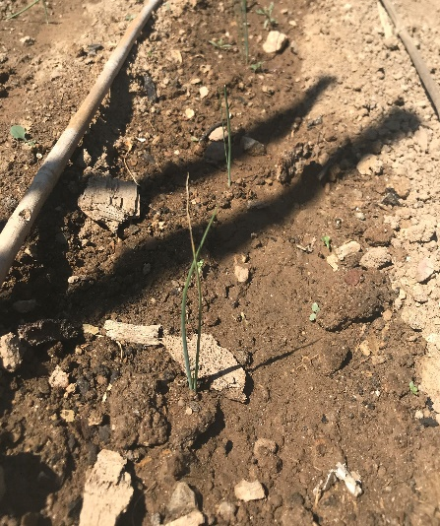 | What plant is this?  Who is growing it, Mrs Harrison or Mrs Powdrill?  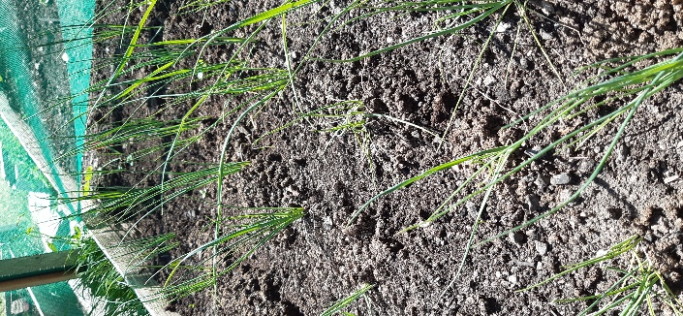
What plant is this?  Who is growing it, Mrs Harrison or Mrs Powdrill?  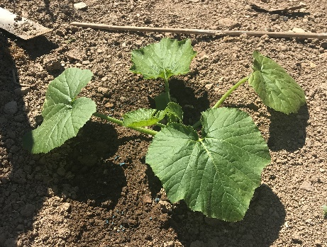 | What plant is this?  Who is growing it, Mrs Harrison or Mrs Powdrill?  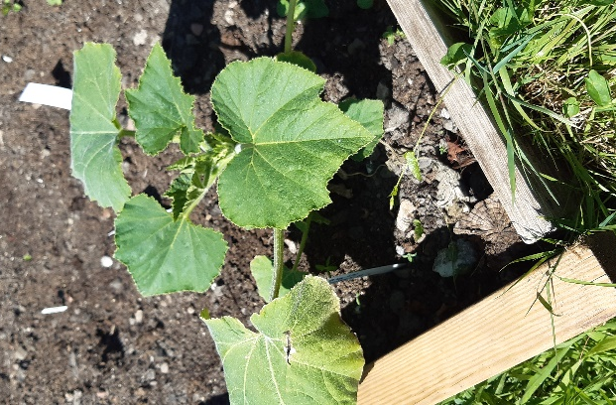
What plant is this?  Who is growing it, Mrs Harrison or Mrs Powdrill?  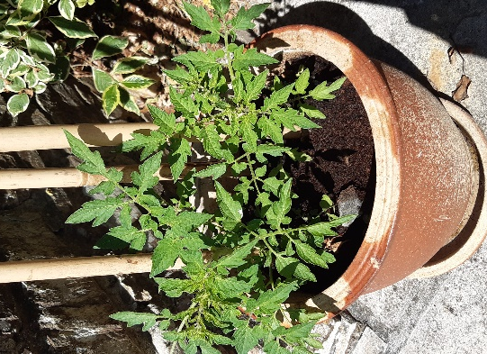 | What plant is this?  Who is growing it, Mrs Harrison or Mrs Powdrill?  