Poetry Activity 3
Today we are learning:
- To we are going to write similes.
Success Criteria | Tick
I can write a simile using the word as
I can write a simile using the word like

Poets can write a poem about anything. They can write a poem about a thought, an emotion, or even tell a story.
Yesterday we recapped what a simile is. Today, we are going to practice writing similes. Before we begin writing we need inspiration! Can you draw a picture of your favourite animal?
Now that we have our inspiration, we can begin to write similes. Below I have a drawing of a lion. Underneath I have written two examples of similes that are about the lion.
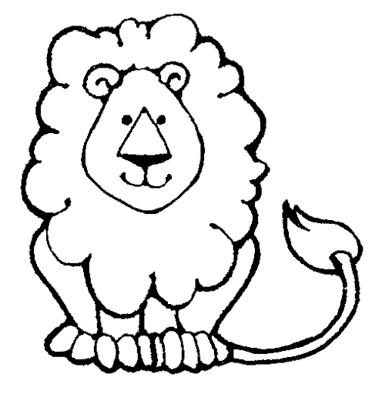
The lion’s mane is as fluffy as a cloud. The lion’s fur was golden like the sun.
Have a go at writing two similes about your favourite animal using the words ‘as’ and ‘like’.

