Odd One Out: Burly Bridges
Today we are going to put our observation skills to the test. Below are three pictures of different railway bridges.
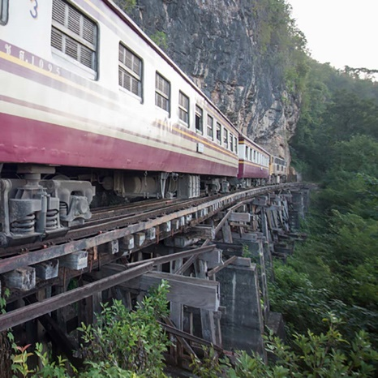
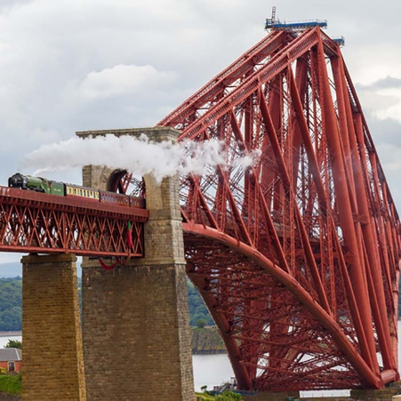
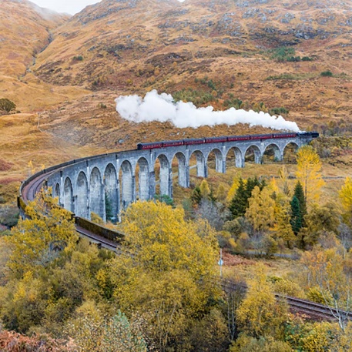
Have a look at the different pictures, what similarities and differences can you see between each of the bridges? Does each bridge look the same? What do you think the bridges are for? Where do you think these bridges might be found? Discuss your thoughts with an adult and write your thoughts in the table below.
What they have the same | What is different
Which bridge do you think is the odd one out? Write your answer in the box below and explain why you think that one is the odd one out.

All three pictures are of railway bridges from around the world.
In all the bridges the railway tracks are made of a metal called steel. The reason the tracks are made from steel is because it is a cheap but strong and hard material.
The materials that is used to build the actual bridge in each picture differs.
The first image shows a wooden bridge in Thailand. Wood is a strong material and is plentiful in this area of the world, as Thailand is covered in forest. Wood is also a natural and renewable material.
The red bridge is the Forth Bridge in Scotland. This is a viaduct that is built of concrete and steel. Concrete is a man-made material which is strong, hard and resistant to weathering.
Extension
Can you make a bridge? What can your bridge support?

