Odd One Out: Unusual Shelters

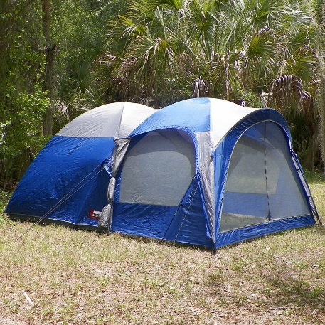
Many different materials are used to construct different houses, as well as, many different methods for constructing them. Below are three pictures of different types of shelters around the world.
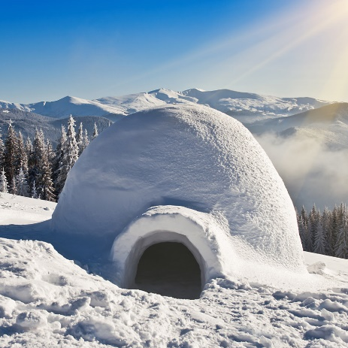
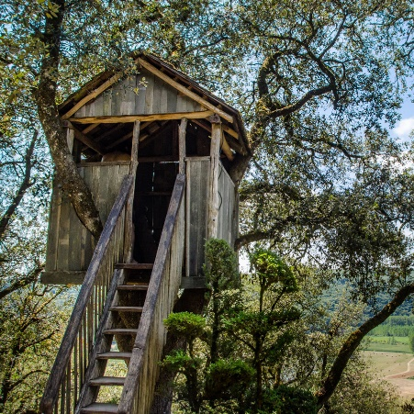

Look at the three pictures above, think about their appearance, discuss with an adult what do these three shelters have in common? What is different between the shelters? Where do you think we might find these shelters?
Which one do you think is the odd one out? Explain your reasoning.

These shelters are all temporary types of shelters built within an environment from either materials that were taken with you or collected from the environment. Treehouses are platforms or buildings that are built into a tree. They are usually constructed around mature trees and above ground level. In tropical countries treehouses are built to protect the people living in them from wild animals and to store food from scavenging animals. Treehouses are usually built from wood which can be strong and stiff and can also be light and flexible.
Igloos are domed shaped and are unique because they are made from blocks of snow or ice that lean against each other without any other support. Blocks of dry, hard snow are cut out using snow spades and saws. The blocks are then placed in a circle, usually built on top of a hole. The circle gradually gets smaller and smaller to create the dome shape. Snow is a great insulator and the air pockets that are trapped in the snow help keep things warm. Igloos can potential last forever as long as the temperature outside is 0’C or lower, otherwise it would start to melt.
Tents can be made from several different materials. The more common materials are cotton canvas, nylon, felt and polyester. Each material has different benefits some such as cotton are more waterproof than others. Nylon is a stronger material that is also lightweight.

