Are materials see-through?

Today we are going to be investigating whether materials are transparent or not. What do we mean when we say a material is transparent? When an object is transparent, it means that light can completely pass through it, therefore you can clearly see through it. An example of something that is transparent is a window in your house, if you look through a window and see outside of your house (a garden or even the street) then the window is transparent.
Why might you think it is important for some materials to be transparent? Share your thoughts with an adult.
In today’s investigation we are going to test some different materials to see if they are transparent or not. For this investigation I would like you to find 4 different types of materials. I have found: a plastic water jug, a glass cup, a tea towel and a cereal box. You will also need a torch.
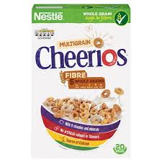
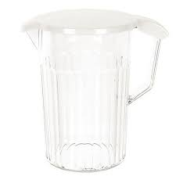
Plastic
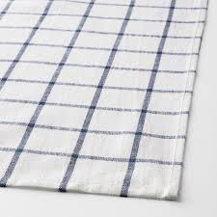
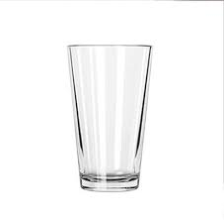
Cardboard
Cloth
Glass
Begin by placing your first object on a table and using the torch shine a light through the object. Does the light appear to go through the glass or does the object stop the light? Record your findings using the table below.
Material Used | Does light pass through the object? | Is the object transparent?

