Natural or Man-made?
Have a look at the six pictures below. What do you notice about them?
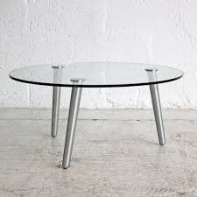
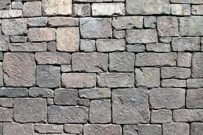
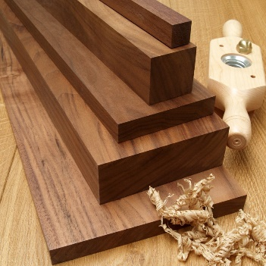

- Wood 2. Glass 3. Stone
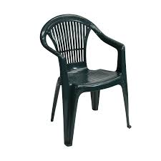
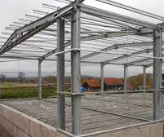
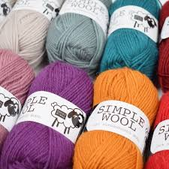

4. Wool 5. Steel 6. Plastic
Can you organise the objects into two groups? The first group is Natural Materials and the second group is Man-made Materials.
Today we are going to be exploring natural or man-made materials. Have a think about what we mean by natural materials and man-made materials. Share your thoughts with an adult. Natural materials are materials that can be found naturally. They may need to be dug out of the ground (stone), grown (wood) or taken from living things (wool). Man-made materials are natural materials that have been changed through chemical process by humans.
Make a list of things that are man made and another list of things that are natural.

