What are Minibeasts?

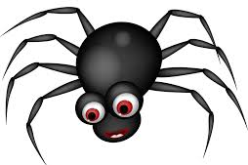
There are millions of different species of minibeast around the world. The scientific name for minibeasts is invertebrates. These can be crustaceans, insects, millipedes, centipedes, and arachnids.
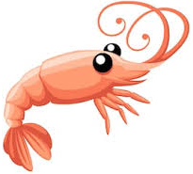
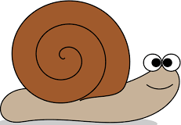

Minibeasts do not have an internal skeleton like humans so they need something to protect their soft and squishy insides. Some minibeasts like a snail will have a hard shell to protect them, other minibeasts, like ants or spiders, may have a thin but hard protective layer on the outside of their body called an exoskeleton.

Today you are going to go explore your back gardens for any minibeast that you can find. Minibeasts live in a variety of different habitats so be sure to look under any rocks, in bushes, on trees or flowers, and in the soil.
Use the checklist provided to ensure that you do not forget any that you have seen.

Extension
You can take the exploration further by looking for minibeasts the next time you go out for a walk or to the beach. Do you think you will find different minibeast depending where you go? Why?

