Where do minibeasts live?

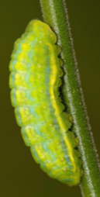
Many different minibeasts live in many various microhabitats. They live in a microhabitat where they can find food, water and shelter. Today, we are going to be exploring some of the microhabitats that minibeasts live in.

Caterpillars like to live on top and underneath leaves. This is so they can hide by blending into the leaf. This is known as camouflage. By being camouflaged the caterpillar can protect themselves so that they cannot be seen by predators. Caterpillars can also use their camouflage to help catch what they want to eat.

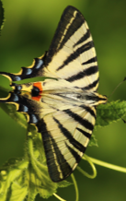
Butterflies survive in a variety of habitats around the world. Some butterflies are awake during the day and other are awake during the night, we call this type of butterflies nocturnal. Some butterflies prefer to live in the summertime when it is nice and hot. Other types of butterflies live in the winter. Butterflies tend to live in grasslands that have lots of wildflowers that can be used as food for which the caterpillars eat before transforming into butterflies.
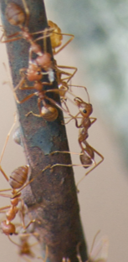

Ants mostly live underground and in big families called colonies. There are lots of insects that they can eat underground. Ants do not have any ears, so they “hear” use their feet to feel the vibrations in the ground.

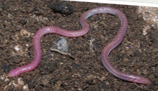
Worms like to live anywhere where there is soil. Worms help to keep the soil they live in healthy as they dig tunnels that let air and water into the soil and to the roots of the plants.
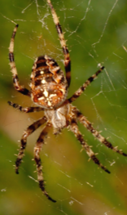
Spiders can live just about anywhere. They do well in all types of habitats but need to find shelter when the weather gets colder. Like caterpillars, the colour of a spider’s body can help them to blend in with their surroundings. To catch their dinner, spiders build webs to trap small insects.
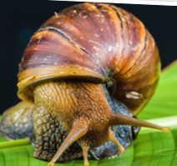
Snails can survive nearly everywhere and are found all around the world. Some snails can survive in water and other snails can even live in the desert. Snails prefer to live near rocks and plants to hide from natural predators.

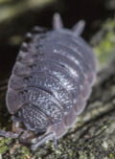
Woodlice like to live in dark damp places such as compost heaps and woodland gardens. There are the only species of crustaceans (other examples of crustaceans are crabs, lobsters and shrimp) that live on the land and not in water. To protect themselves from predators they curl up into a ball.

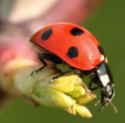
During the summer, ladybirds live in shrubs, branchers and flowers. When the weather gets colder, they find hiding places to protect themselves such as tree stumps or cracks in wood. They then use this place to hibernate. When hibernating, ladybirds huddle together to keep warm.

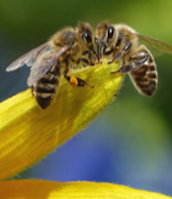
Honeybees like to live in areas with lots of flowering plants such as gardens or meadows. In their natural habitat, they build nests inside holes in trees to keep themselves safe from predators. In colder climates, honeybees store more honey to prepare for the winter.

