Crafting a Minibeast
Today we are going to have fun using our arts and crafts skills to make a minibeast. This is what I did.
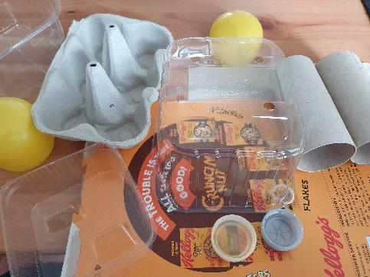
Step 1
Firstly, I gathered the materials that I would be using to make my minibeast. As you can see, I selected a range of recyclable materials.

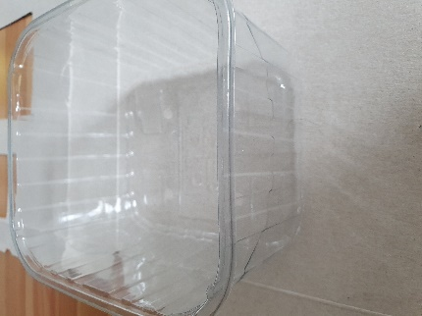
Step 2
Next, I needed to decide on what minibeast I was going to make. Looking at the materials, I thought this plastic carton would make a good body for a ladybird. I then began to start on the ladybird wings. I decided to use an empty cereal box for this bit so traced round my ladybird’s body so that the wings were the right size.

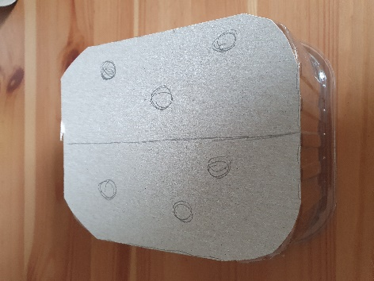
Step 3
Once I had traced round, I cut my wings out and marked where I was planning to put the ladybird’s signature spots. Using PVA glue I then stuck the wings to the body.

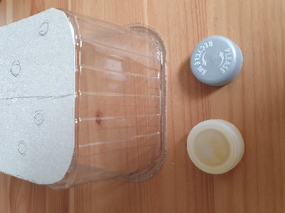
Step 4
Next, I decided to stick on the ladybird’s eyes. For the eyes I thought I would use the plastic lids. Just like with the wings I used PVA glue to stick both eyes to the ladybird’s body.

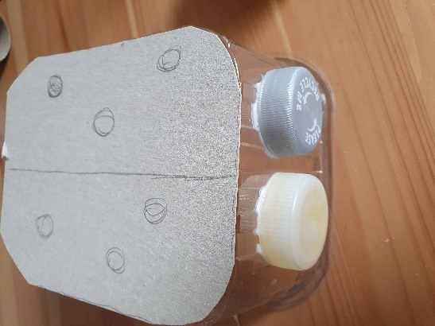
Step 5
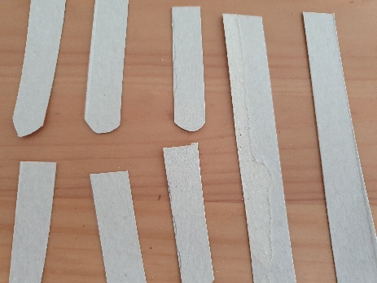
I thought that my ladybird was coming along quite nicely. I then noticed that my ladybird did not have any legs. I went back to my cereal box and cut out 3 long strips which I then cut each strip into 2 smaller pieces.

Step 6
Once the legs had been cut to the size that I placed a small bit of PVA glue onto the end of each leg and stuck it to the bottom of the ladybird’s body. I then repeated this for the 5 remaining legs.

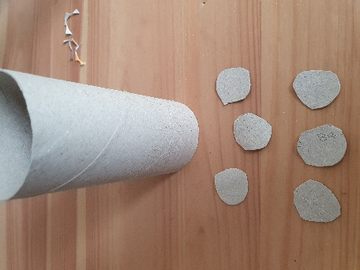
Step 7
I really wanted the ladybird’s spots on her back to stand out so I used some loo roll cardboard to make 6 spots. I used this cardboard instead of the cereal box so that the spots would stand out. Then I put a small amount of PVA glue onto each spot and placed the spots onto the spots that I drew earlier.

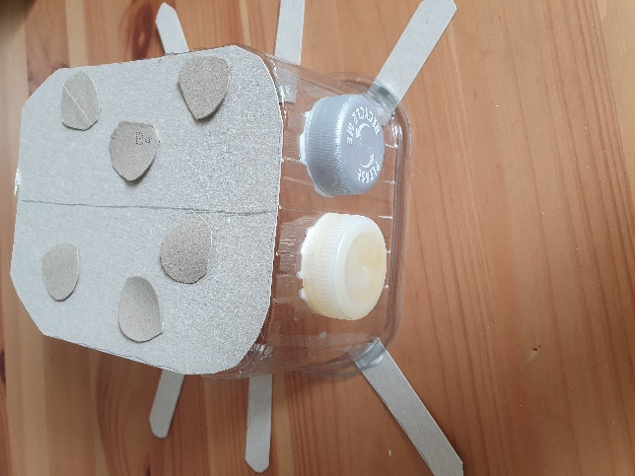
And they we have it, my finished ladybird. Of course, if you wanted to use could then colour your minibeast in using colours pencils, pens, or paint.

What colour would you make my ladybird? I can’t do it at home as I don’t have the things I need! What a shame!
What do you have to colour yours with? Remember to send Mrs Harrison or Mrs Powdrill a photograph of your creation so they can send it to Mr Bailey.

