**Spelling games ideas**

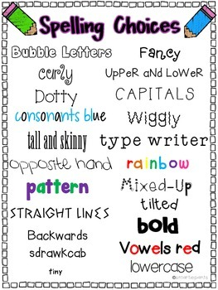

Balloon/Ball Bonanza

Use either a balloon/ball to hit/pass to one another, spelling one letter at a time as they pass it.

Spelling choices

Some children enjoy getting ‘arty’ and love to spell words in different colours, or styles.

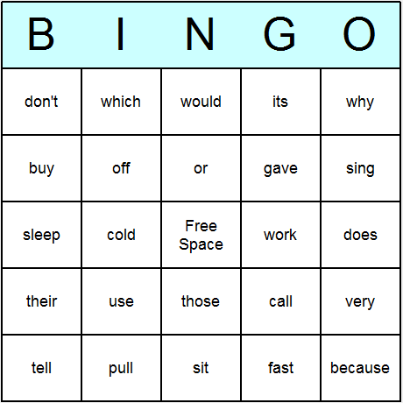

Bingo

Get the children to write down their spellings. To win, each one must be spelt correctly.

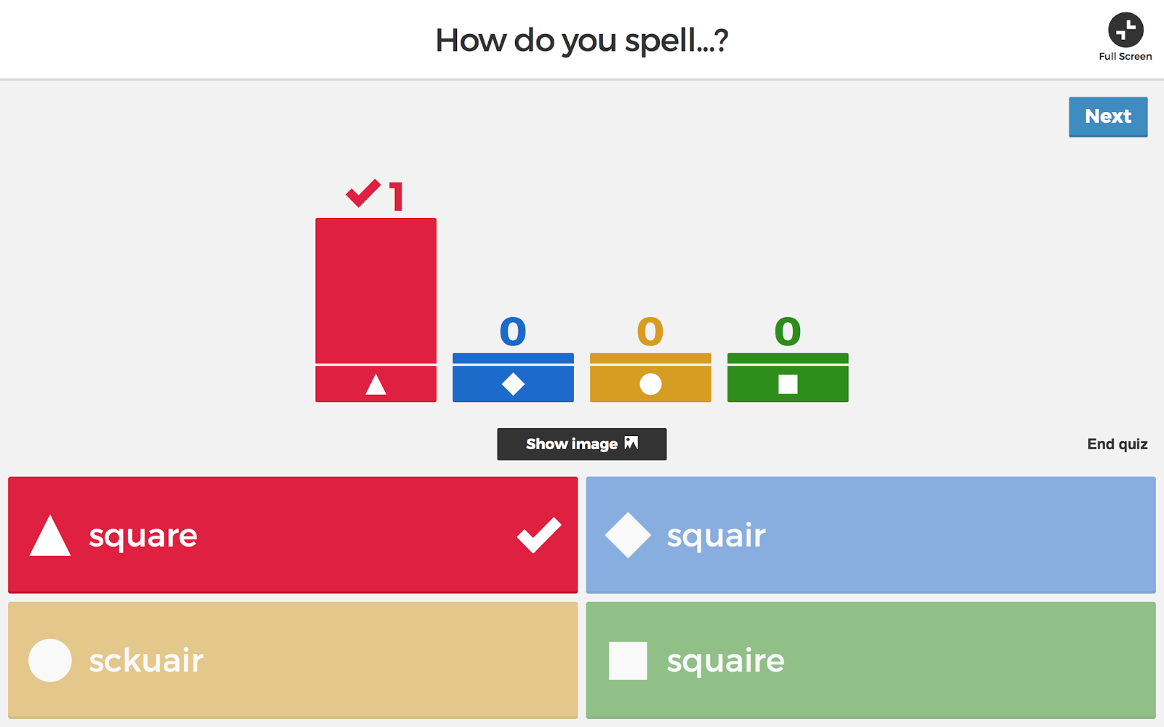

Invisible writing

Write one of the spellings on their partner’s backs and they have to guess it.

Prefix and Suffix Snap

Children turn over a suffix/prefix and find words that snap with it.

Kahoot

This requires ICT equipment. Create a quiz of the spellings and children have to select the correct answer.

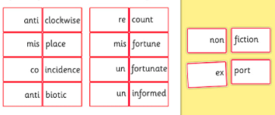

Anagrams

Have the spellings written in the wrong order and children figure out each word.

Spot the mistake

Similar to Kahoot, write the spelling in 3/4 different ways. One way is the correct and the others are wrong. Get a partner to circle the correct spelling.

Speed writing/typing

This can be done using ICT or if this in not available, can be written instead. Give them 30/60 seconds to type the word as many times as they can.

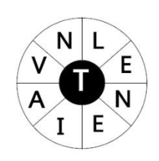

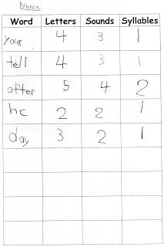

Chalk spelling

Use chalk outside to spell as a group, or children can work in partners to suggest words. Good peer assessment to check the spelling is correct.

Working with words

It is important to understand the components of each word so children can identify how many letters, sounds, syllables and even vowels and consonants.

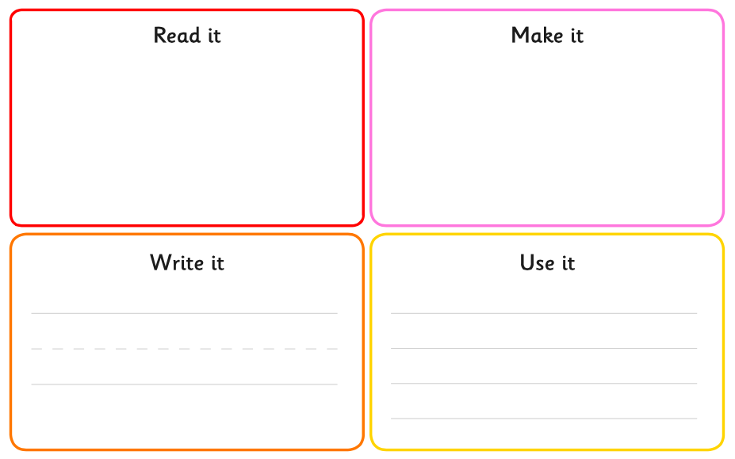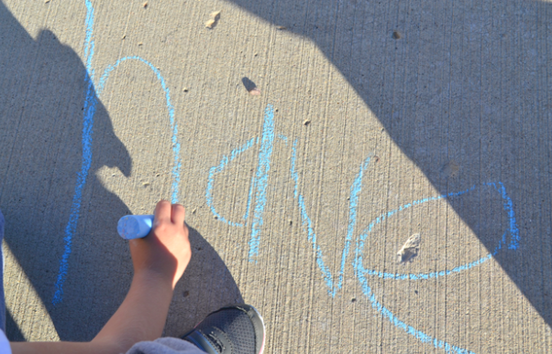

Say it, make it, write it, use it

This is self-explanatory however, the make it can be used in a variety of creative ways and allow the children to choose. This can be play dough, beads, cereal, magnetic letters, scrabble letters etc.

**Spelling games ideas**

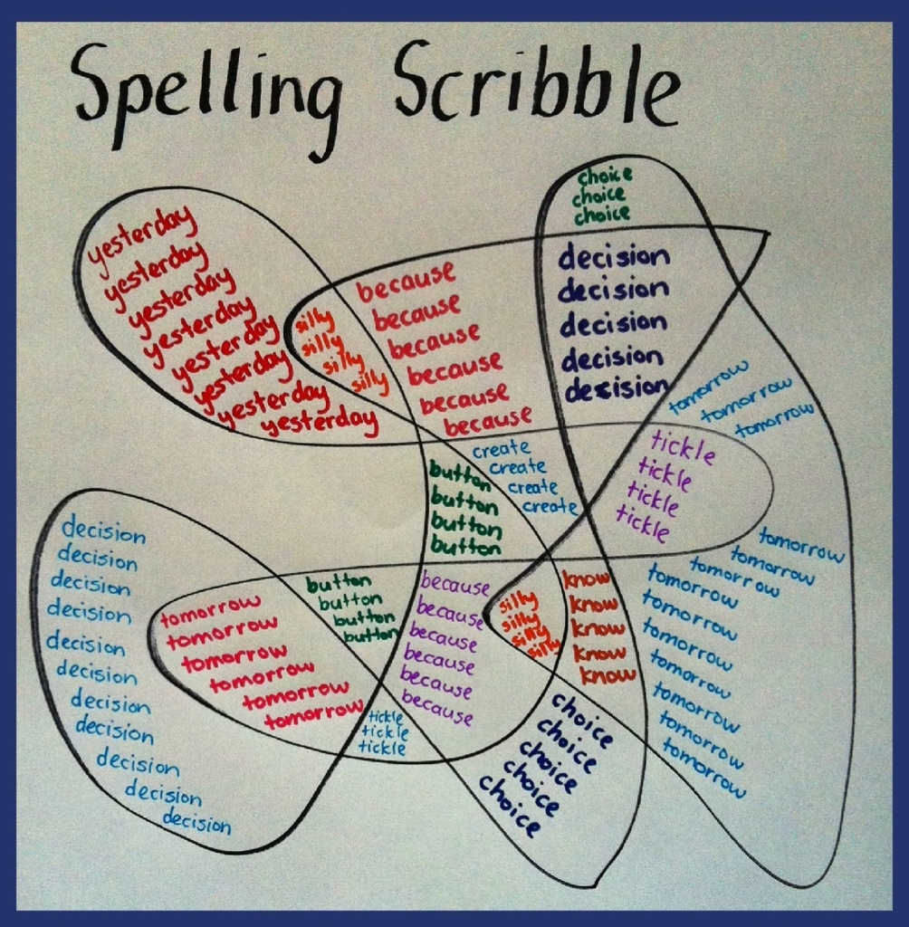

Tic-Tac-Toe

Children work in partners and choose a word each to get 3 in a row, column or diagonal. Once completed choose other words. This allows them to peer assess if there is a spelling error.

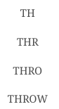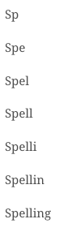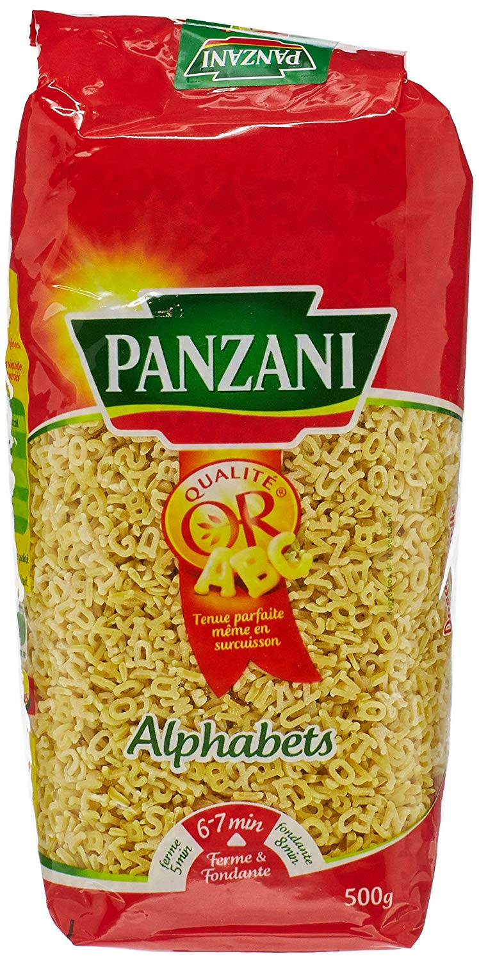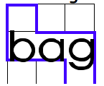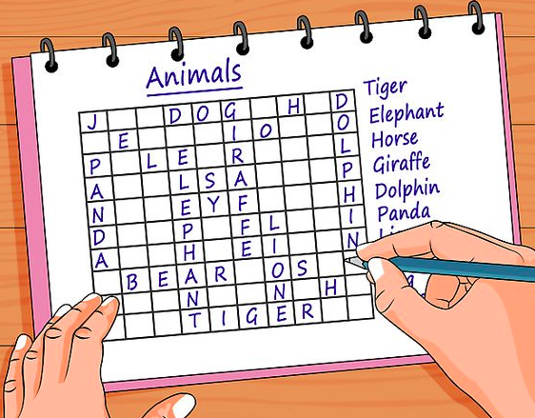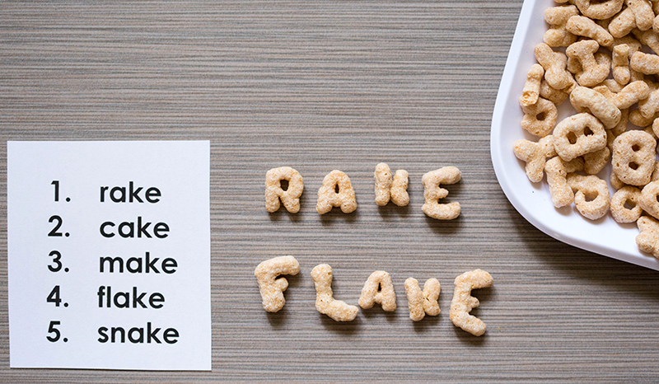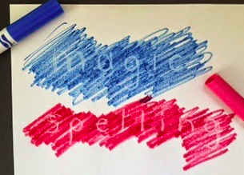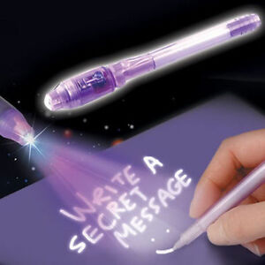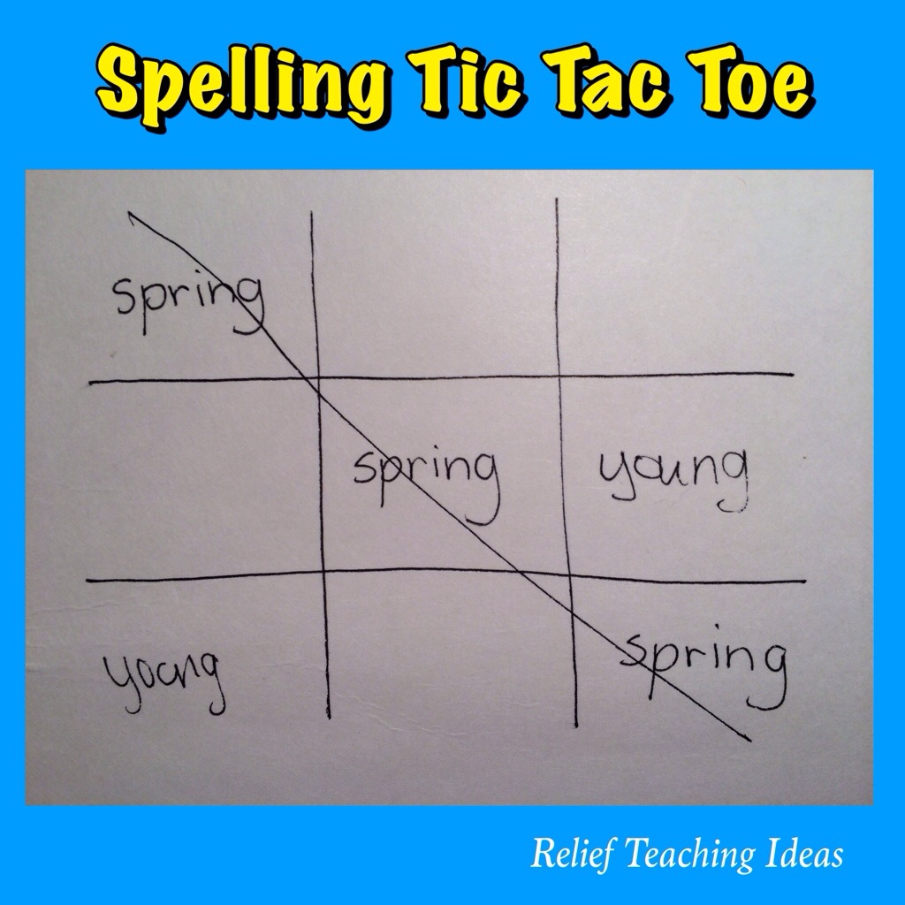

Stairs or pyramids

Construct each spelling starting with two letters and add a letter underneath each time.

Spelling Boom

Write the spellings onto lollipop sticks. Make sure to write BOOM on a few of the sticks. Each player blindly draws a stick and hands it to someone else to read. If they spell it correctly, they keep the lollipop stick, if it’s wrong they must put it back. If they choose BOOM they must put back all of the words they have collected so far. The person with the most at the end wins.

Cereal spelling

Working with a partner, give each other the spelling and then use alphabet cereal to spell it. Check both have spelt it correctly. This can also work with pasta letters.

Charades

Act out the word and a small group has to guess the word. Whoever guesses correctly has to then spell the word.

Magic Pens

This is great for the demotivated spellers/writers, as people can’t see whether they have got it wrong. You can purchase magic pens or use white crayons and water colours/water based markers.

Surround words

Write words in graph paper (it can be done on lined paper if necessary). Write ‘middle’ letters, one letter in each box. Use two boxes for ascenders and descenders.

Make your own word search

Get a blank word search template and then the children have to use their spellings to create their word search. Ensure you give them time to swap with a partner to incorporate sight recognition.

Forehead Detective

In pairs, get your partner to write one of spellings and stick it secretly to their partner. They then have to ask questions to figure out the word. When they are correct, they need to spell it before taking it off their head.

Spelling scribble

Children draw a big scribble and then write the different words in each section of the scribble to fill the space. They could use different colours for each word to visually see it clearly.