Art – Follow these steps to draw different fossils. If you have white chalk or paint you could draw these on black or brown paper or card. Try out different techniques by drawing them with thin and thick lines.
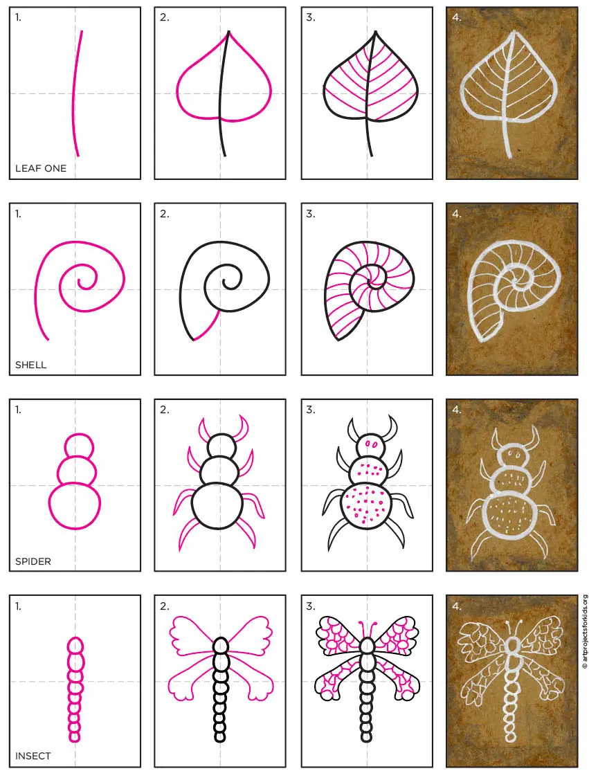
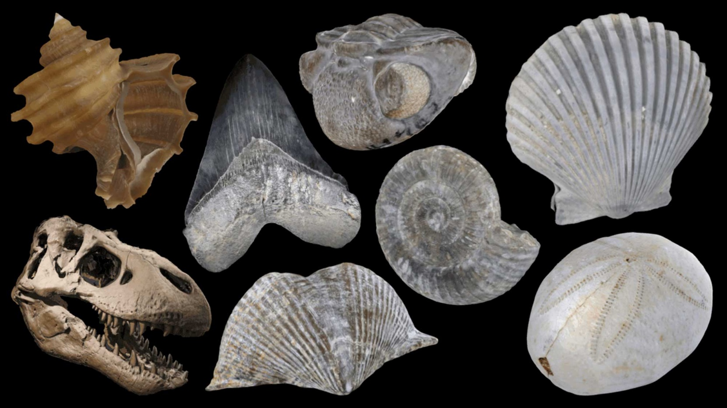
Challenge – Try drawing these fossils using just a pencil and paper. Try pressing hard for dark lines and gently for light coloured lines.

